**Recruiting Assistance For The HR Managers - (Developer)**

To make the existing app more efficient for the HR team we create custom objects and

relationships to store and access the data more efficiently. We install an unmanaged package in

the org to get metadata that acts as existing data in the recruitment app.

https://trailhead.salesforce.com/content/learn/projects/build-a-data-model-for-a-recruiting-app

### Salesforce

Salesforce is your customer success platform, designed to help you sell, service, market, analyze, and connect with your customers.  
  
Salesforce has everything you need to run your business from anywhere. Using standard products and features, you can manage relationships with prospects and customers, collaborate and engage with employees and partners, and store your data securely in the cloud.  
  
So what does that really mean? Well, before Salesforce, your contacts, emails, follow-up tasks, and prospective deals might have been organized something like this:  
<https://youtu.be/r9EX3lGde5k>  
  
There are 5 types of salesforce editions:  
  
1. Essentials: Designed for small businesses getting started with CRM to boost sales or service productivity. It includes a setup assistant and administration tools to customize your deployment as you grow.  
  
2. Professional: Designed for businesses requiring full-featured CRM functionality. It includes straightforward and easy-to-use customization, integration, and administration tools to facilitate any small to midsize deployment.  
  
3. Enterprise: Meets the needs of large and complex businesses. It gives you advanced customization and administration tools, in addition to all the functionality available in Professional Edition, that can support large-scale deployments. Enterprise Edition also includes access to Salesforce APIs, so you can easily integrate with back-office systems.  
  
4. Unlimited: Maximizes your success and extends it across the entire enterprise through the Lightning Platform. It gives you new levels of platform flexibility for managing and sharing all your information on demand. Includes all Enterprise Edition functionality, Premier Support, full mobile access, unlimited custom apps, increased storage limits, and other features.  
  
5. Developer: Provides access to the Lightning Platform and APIs. It lets developers extend Salesforce, integrate with other applications, and develop new tools and applications. Developer Edition also provides access to many of the features available in Enterprise Edition.  
  
  
NOTE: Salesforce doesn’t provide technical support for Developer Edition. But you can ask for help from developer community message boards after you register for the Lightning  
  
Platform developer website: developer.salesforce.com.

**Creation Of Developer Org**

A Developer org has all the features and licenses you need to get started with Salesforce.

1. Search Developer.salesforce.com  
  
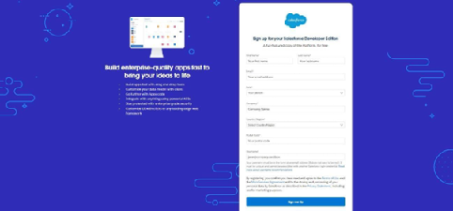  
2.Enter the following details like First name, last name, Email, Role, Company, Country/Region, Postal code, and Username must be unique.  
  
3.Click sign me up, After a few min you will reserve a mail salesforce org and by using the verify account link you can create your new password.  
  
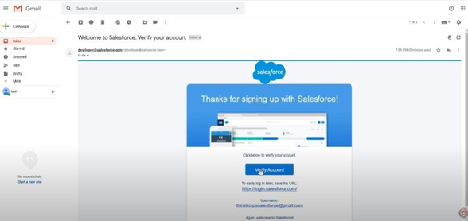  
  
4.Click save.  
  
5.Search login.salesforce.com  
  
6.By using username and password you can into the salesforce org.

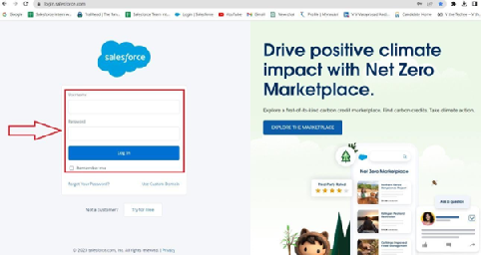

The setup page will appear as below.

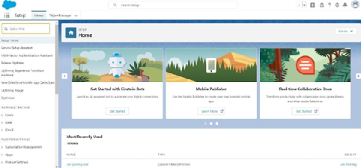

Create a developer org and login with your login credentials.

**Package Installation**

**Package installation for Recruiting App**  
  
In Salesforce, a package is a collection of Apex classes, triggers, Visualforce pages, and other components that can be installed into an organization. There are two types of packages: managed and unmanaged. Managed packages are developed and distributed by ISVs (Independent Software Vendors) and can be installed from the Salesforce AppExchange, while unmanaged packages are created and distributed by Salesforce administrators within an organization. To install a package, an administrator can navigate to the AppExchange, find the desired package, and click the "Install" button. The administrator will then be prompted to log in to their Salesforce organization and provide permission to install the package.  
  
  
1. Go to the Package Installation Link.  
2. Select Install for Admins only  
3. Click install.

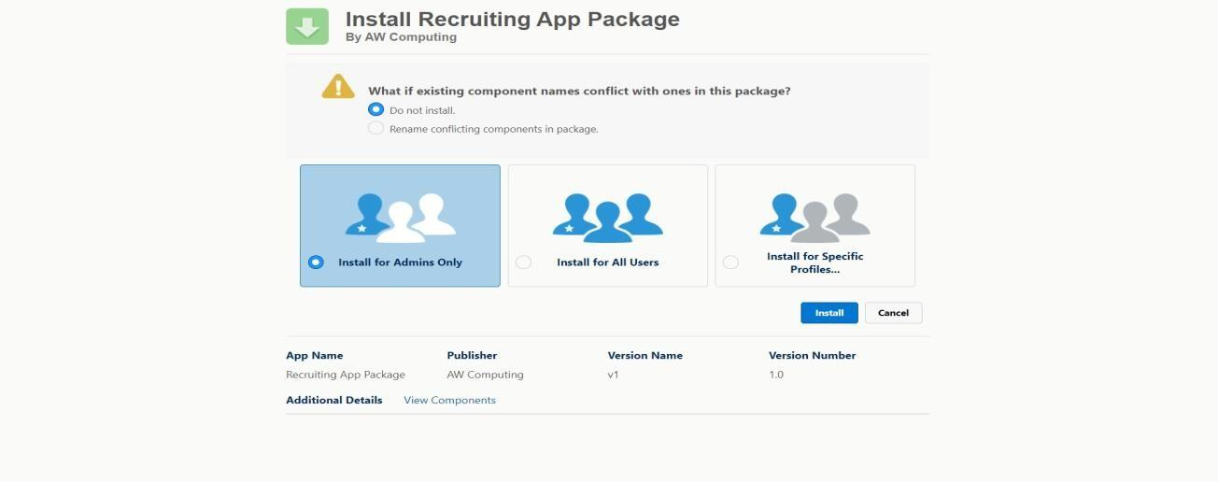

**Object**

**What is an object?**

Salesforce objects are database tables that permit you to store data that is specific to an

organization. It consists of fields (columns) and records (rows).

Salesforce objects are of two types:

1. Standard Objects: Standard objects are the kind of objects that are provided by

salesforce.com such as users, contracts, reports, dashboards, etc.

2. Custom Objects: Custom objects are those objects that are created by users. They supply

information that is unique and essential to their organization. They are the heart of any

application and provide a structure for sharing data.

### Create A Custom Object For Job Posting Sites

To create a custom object, follow these steps :

1. From setup click on object manager.

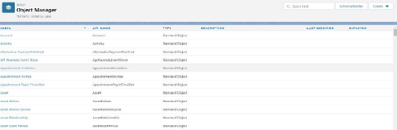  
2.Click create, select custom object.

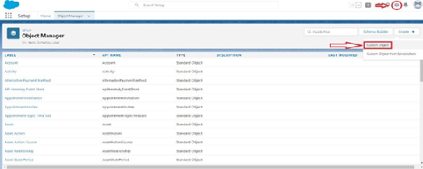

3.Fill in the label as "Job Posting Site".  
4.Fill in the plural label as "Job Posting Sites".  
5.Record name : "Site Name"  
6.Select the data type as "Text".  
7.In the Optional Features section, select Allow Reports and Track Field History.  
8.In the Deployment Status section, ensure Deployed isselected.  
9.In the Search Status section, select Allow Search.  
10.In the Object Creation Options section, select these options:Add Notes and Attachments related list to default page layout Launch New 11.Custom Tab Wizard after saving this custom object  
Leave everything else, and click Save.

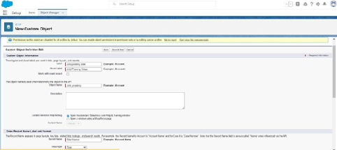

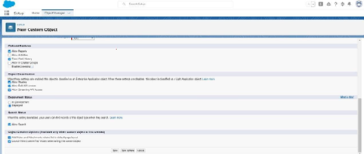

### Create A Custom Object For Reviews

To create a custom object, follow these steps :

1. From setup click on object manager.
2. Click create, select custom object.
3. Fill in the label as "Review".
4. Fill in the plural label as "Reviews".
5. Record name : "Review Number"
6. Select the data type as "Auto Number".
7. Under display format enter "REV-{0000}".
8. Enter the starting number as 1.
9. In the Optional Features section, select Allow Reports and Track Field History.
10. In the Deployment Status section, ensure Deployed is selected.
11. In the Search Status section, select Allow Search.
12. In the Object Creation Options section, select Add Notes and Attachments related list to default page layout.
13. Leave everything else as is, and click Save.

**What Is A Junction Object?**

In Salesforce, a junction object is a custom object that is used to create a many-to-many relationship between two other objects. It connects two objects together by creating two  
one-to-many relationships, allowing data from both objects to be associated with each other in a single record. For example, if you have a custom object for "Projects" and another for "Teams," a junction object could be used to connect individual team members to multiple projects.  
  
**Create a Junction object for Job Posting**

1. To create a custom object, follow these steps :
2. From setup click on object manager.
3. Click create, select custom object.
4. Fill in the label as "Job Posting".
5. Fill in the plural label as " Job Postings".
6. Record name : " Job posting number "
7. Select the data type as "Auto Number".
8. Under display format enter " JOBPOST-{0000}”
9. Enter the starting number as 1.
10. In the Optional Features section, select Allow Reports and Track Field History.
11. In the Deployment Status section, ensure Deployed is selected.
12. In the Search Status section, select Allow Search.
13. In the Object Creation Options section, select Add Notes and Attachments related list todefault page layout.
14. Leave everything else as is, and click Save.

### Tabs

What is Tab?  
  
In Salesforce, a tab is a user interface element that allows users to navigate to different sections of the platform, such as Accounts, Contacts, Leads, and Opportunities. Tabs can also be used to access custom objects and custom pages. They are typically located at the top of the screen and can be customized to fit the needs of the organization.  
  
  
  
There are mainly 4 types of tabs:  
  
**Standard Object Tabs:**  
Standard object tabs display data related to standard objects.  
  
**Custom Object Tabs:**  
Custom object tabs display data related to custom objects. These tabs look and function just like standard tabs.  
  
**Web Tabs**:  
Web Tabs display any external Web-based application or Web page in a Salesforce tab.  
  
**Visualforce Tabs:**  
Visualforce Tabs display data from a Visualforce Page.  
  
NOTE: we won’t be dealing with web tabs and visualforce tabs later.

Now create a custom tab.

1.Click on Home tab, enter Tabs in Quick Find and select Tabs.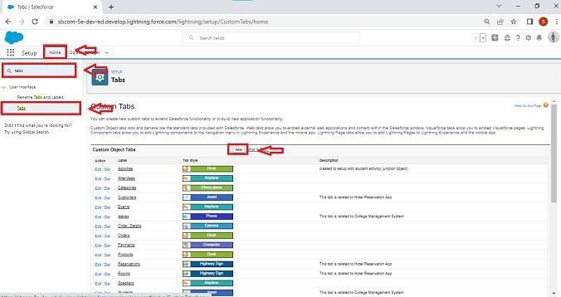

2.Under custom object tabs, click New.

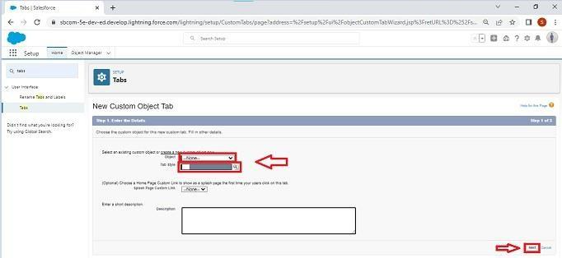

3.For Object, select Job Posting Sites.  
4.For Tab Style, select any icon.  
5.Leave all defaults as is. Click Next, Next, and Save.

**Creation Of Reviews Tab**

Now create a custom tab.

* Click on Home tab, enter Tabs in Quick Find and select Tabs.
* Under custom object tabs, click New.
* For Object, select Reviews.
* For Tab Style, select any icon.
* Leave all defaults as is. Click Next, Next, and Save.

**Creation Of Job Postings Tab**

Now create a custom tab.

* Click on Home tab, enter Tabs in Quick Find and select Tabs.
* Under custom object tabs, click New.
* For Object, select Job Postings.
* For Tab Style, select any icon.
* Leave all defaults as is. Click Next, Next, and Save.

**Lightning App**

What is an App?  
  
Apps in Salesforce are a group of tabs that help the application function by working together asa unit. It has a name, a logo, and a particular set of tabs. The simplest app usually has just two tabs.  
  
There are 2 types of Salesforce applications:  
  
**Standard apps:**  these apps come with every occurrence of Salesforce as default. Community, Call Center, Content, Sales, Marketing, Salesforce Chatter, Site.com, and App Launcher are included in these apps. The description, logo, and label of a standardapp cannot be altered.  
  
**Custom apps:**these apps are created according to the needs of a company. They can bemade by putting custom and standard tabs together. Logos for custom apps can be changed.

**Adding Job Posting Sites Tab**

1.click    to launch the App Launcher, then click Recruiting and follow the steps  
2. Click the pencil icon at the top right of the screen.

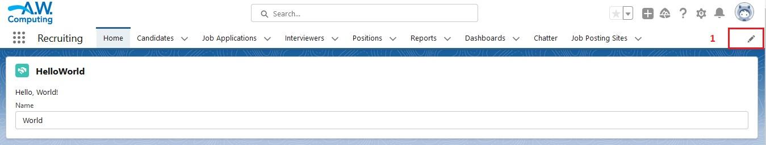

3.Click Add more Items.

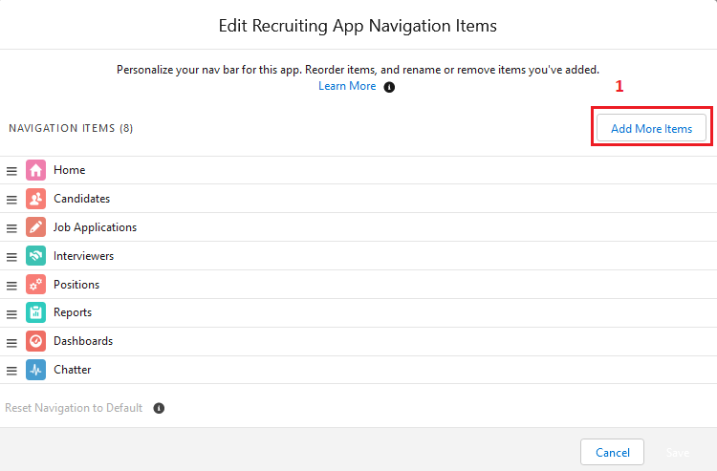

4.From the menu on the left, click All.  
5.Next to Job Posting Sites, click the +.  
6.Click Add 1 Nav item.  
7.Click Save.

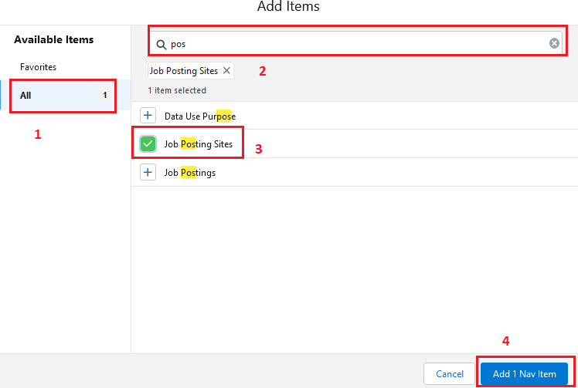

**Fields And Relationships**

What are fields?  
  
Fields in Salesforce represents what the columns represent in relational databases. It can store data values which are required for a particular object in a record.  
  
There are 2 types of fields in Salesforce:  
  
  
**Standard fields:** There are four standard fields in every custom object that are Created By, Last Modified By, Owner, and the field created at the time of the creation of an object. These fields cannot be deleted or edited and they are always required. For standard objects, the fields which are present by default in them and cannot be deleted from standard objects are standard fields.  
  
**Custom fields**: The Custom fields which are added by the administrator/developer to meet the business requirements of any organization. They may or may not be required.

### Create New Field For Job Posting Site

1.Click the gear icon and select Setup. This launches Setup in a new tab.  
2.Click the Object Manager tab next to Home.  
3.Select job posting site.

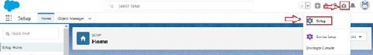

4.Click Field & Relationship than click new.

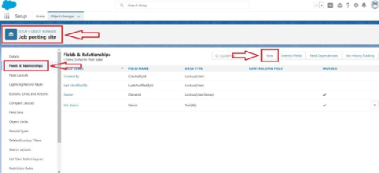

5.Select the data type as URL.

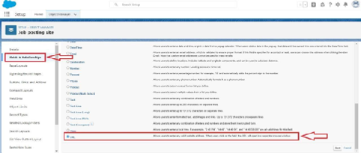

6.Click Next.  
7.For Field Label, enter the Job Posting Site URL.

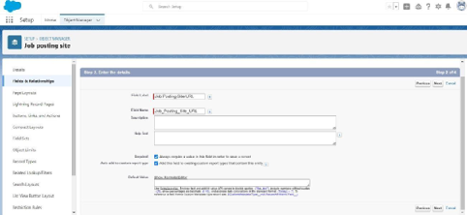

8.Click Next, Next, and click Save & New.

Now let's create the other fields and we must choose the data types of the fields carefully

1.Select Pick list as the Data Type and click Next. For Field Label enter Status.

2.Select Enter values, with each value separated by a new line and enter these values:

* Active
* Inactive

3. Click Next, Next, then Save & New

4. Select the Checkbox as the Data Type, then click Next. For Field Label, enter Technical Site.  
5. Click Next, Next, then Save & New.  
6. Select the Text Area as the Data Type, then click Next. For Field Label, enter Description  
7. Click Next, Next, then Save & New.

**Create pick list field for Job Posting Site object**

* Click on the gear icon and then select Setup.
* Click on the object manager tab just beside the home tab.
* After the above steps, Select Job Posting Site Object
* Now Select Fields and relationships from setup menu of the Attendee object.
* Click new and select Pick list fields ????next and enter label name(Status) and select enter values option(Active, Inactive),next, next and Save
* 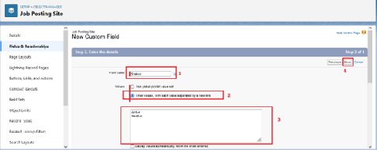

**Create Relationships For Job Posting**

Creating a master-detail relationship between Job posting and job posting site.  
  
1. From Setup, go to Object Manager  
2. Select job posting and click Fields & Relationships.  
3. Click New.

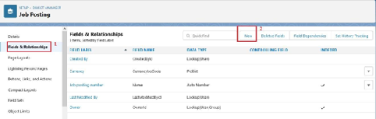  
  
  
  
  
4. Choose Master-detail Relationship and click Next

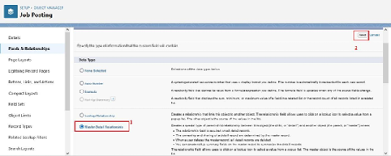

5. Choose the related object (Job Posting Site) and select that object.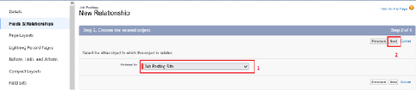

6. Enter the label name(Job Posting Site) for the lookup field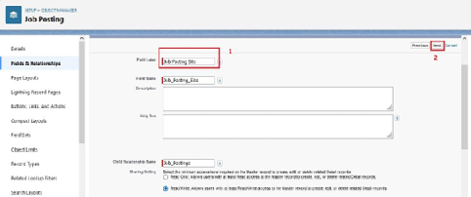

7. Click Next, Next, and Save

Creating a master-detail relationship between job posting and position for job posting object.

1. From setup, click object manager.
2. Select Job posting object, click on field and relationships, click new.
3. Select the data type as Master-detail relationship.
4. Click Next, relate to position.
5. Enter the label Position.
6. Click next, next, next and save.

**Create New Field For Reviews**

Select Picklist as the Data Type and click Next. For Field Label enter Core Competencies.  
Select Enter values, with each value separated by a new line and enter these values:

1

2

3  
4

5  
For Help Text, enter “For this category, rate candidate on a scale of 1 (lowest) to 5 (highest)” Click Next, Next, then Save & New. Follow above steps and create two more pick list with Leadership Skills and  
Experience as the field labels and values same above.

2. Select the Text Area as the Data Type, then click Next. For Field Label, enter Core Competencies Comments.

Click Next, Next, then Save & New.

Follow above steps and create two more text areas with Leadership Skills Comments and

Experience Comments as the field labels.

3. Select Checkbox as the Data Type and click Next. For Field Label, enter Recommend for Hire.

For Help Text, enter “Do you recommend that we hire this candidate? “ Click Next, Next, then Save & New.

4. Select the Text Area as the Data Type and click Next. For Field Label, enter Reason Recommended.

Click Next, Next, then Save & New.

5. Create a lookup relationship field for Interviewer.

Select Lookup Relationship as the Data Type and click Next. For Related To, select Interviewer and click Next.

For Field Label, enter Interviewer. And Click Next, Next, Next, then Save & New.

6. Create a master-detail relationship field for Job Application. Select Master-Detail Relationship as the Data Type and click Next. For Related to, select Job Application and Click Next.

For Field Label, enter Job Application. Click Next, Next, Next and Save.

### Page Layout

What is Page Layout?

In Salesforce, a page layout is a visual design of a page that determines the organization and

arrangement of fields, buttons, and other components on a page. Page layouts can be customized

to show the fields and related information that are most relevant to different users, roles, and

record types. They can also be used to control the visibility and access to fields, buttons, and

other components on a page

**Modifying The Page Layouts**

1. From setup, click on object manager.

2. Click position, then page layouts.

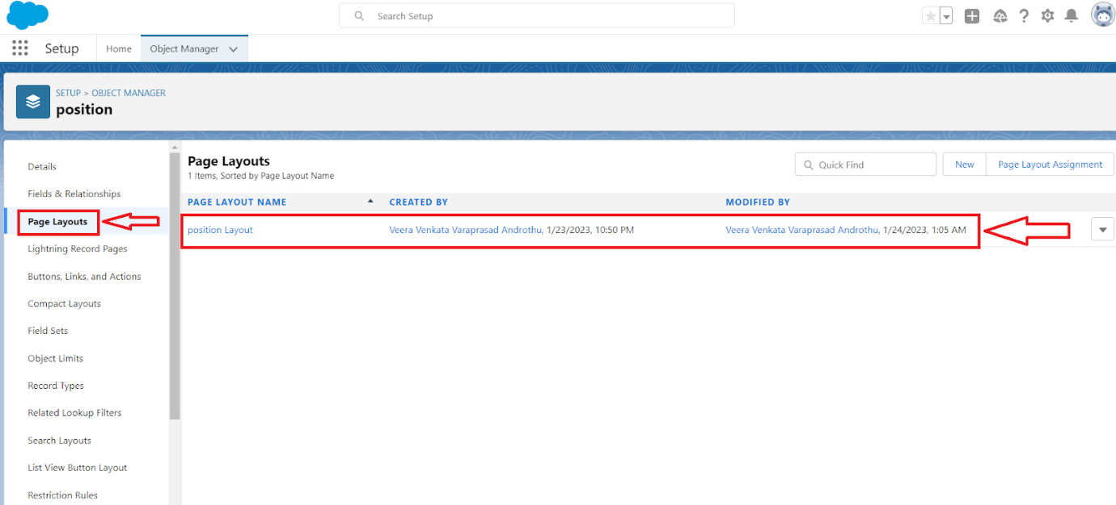

3. Click down array next to the position layout and select edit.

4. Scroll down to the job posting related list, and click the wrench icon in the header to edit it.

5. From the available fields section, select

Job posting site : Status

Job posting site : Technical Site

6. Click add.

7. From the selected fields section, select job posting : Job posting number and click remove

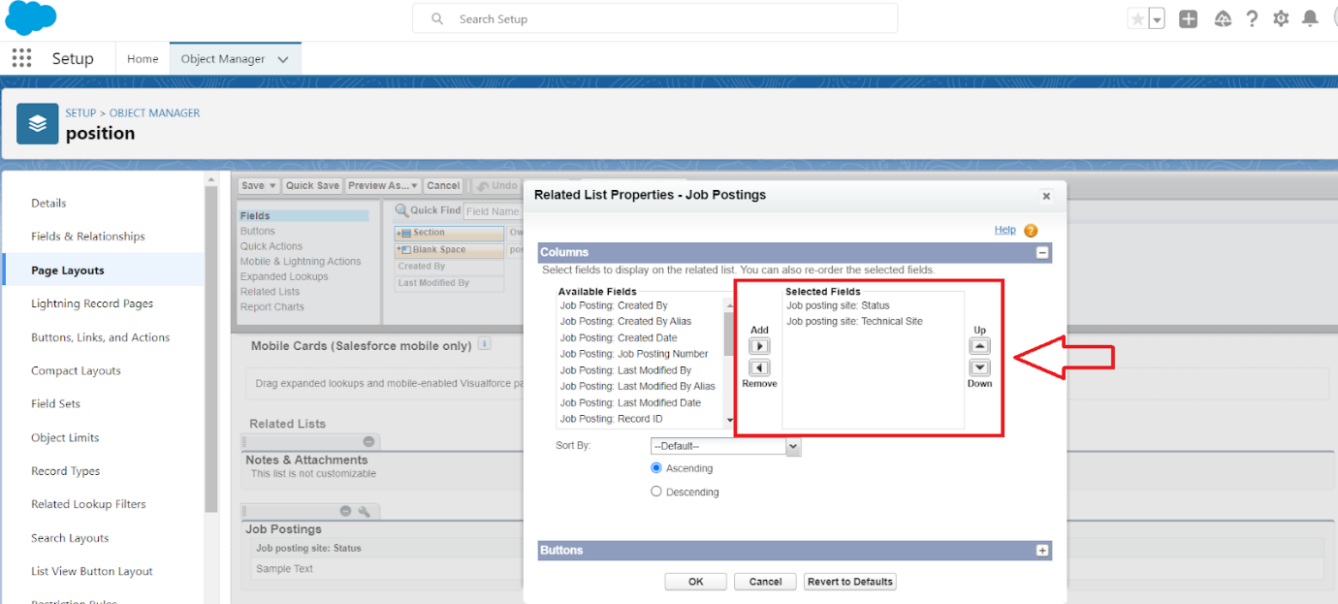

8. Click ok, then save.

### Create A Page Layout For Review Object

Create a Page layout for Review Object

### Validations Rules

What are Validations Rules?

A validation rule is a process which checks out (validate) the inputs given by any user is correct

or not according to your requirement.

### Creating A Validation Rule

To create a validation rule:

Go to object manager, select the object Candidate, scrolldown and click validation rule, New.

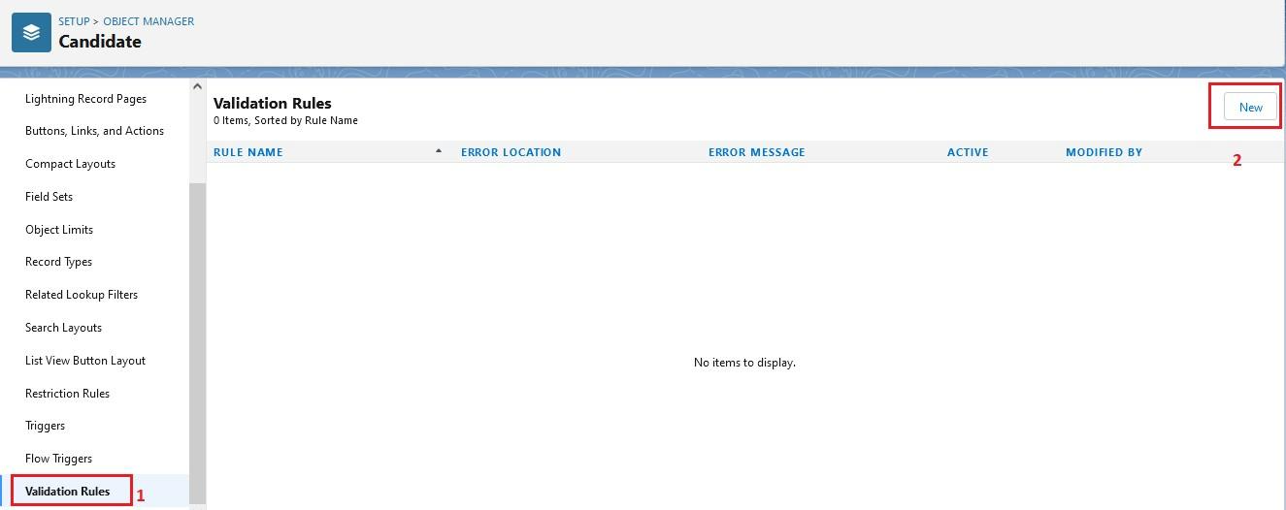

Give details as:

1. Rule name: Phone number validation rule.
2. Active: checked
3. Description: phone number should not be more than or less than 10 digits.
4. Under Error Condition Formula: write the condition using insert field, insert operator, insert function NOT(OR(REGEX(Phone  c, "^[0-9]{10}")))
5. Using check syntax: check if the formula you entered is valid or not.
6. Error Message: Please give a valid phone number
7. Error location: select field
8. Save

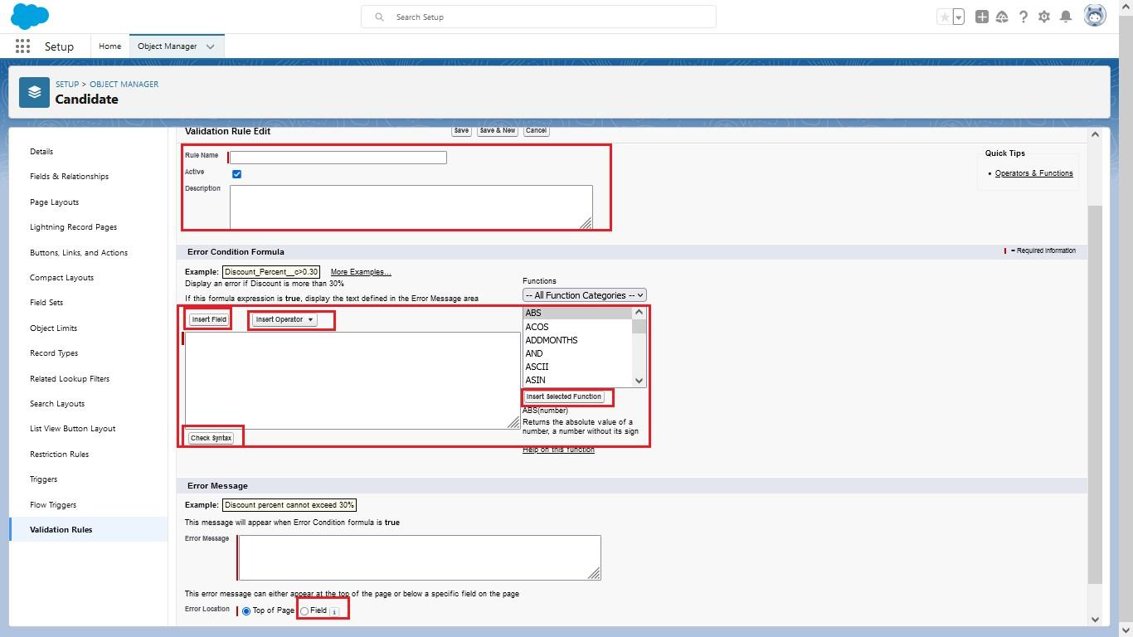  
**Create A Validation Rule For Technical Site Checkbox Is Equal To True.**

Go to object manager, select the object Job posting site, scrolldown and click validation rule, New. Give details as:

1. Rule name: Technical site checkbox true.
2. Active: checked
3. Description: Technical site checkbox should be check.
4. Under Error Condition Formula: write the condition using insert field, insert operator, insert function Technical_Site c != TRUE
5. Using check syntax: check if the formula you entered is valid or not.
6. Error Message: Please select check box of technical site.
7. Error location: select field (Technical site).
8. Save.
9. **Profile**
10. What is a profile?
11. A profile is a group/collection of settings and permissions that define what a user can do in
12. salesforce. A profile controls “Object permissions, Field permissions, User permissions, Tab
13. settings, App settings, Apex class access, Visualforce page access, Page layouts, Record Types,
14. Login hours & Login IP ranges.
15. A profile can be assigned to many users, but user can be assigned single profile at a time.

**Creation On Profile**

From Setup enter Profiles in the Quick Find box, and select Profiles.

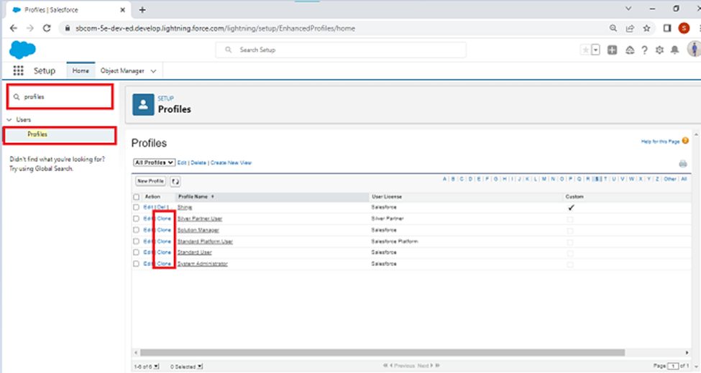

1. From the list of profiles, find Standard User.

2. Click Clone.

3. For Profile Name, enter Event user profile.

4. Click Save

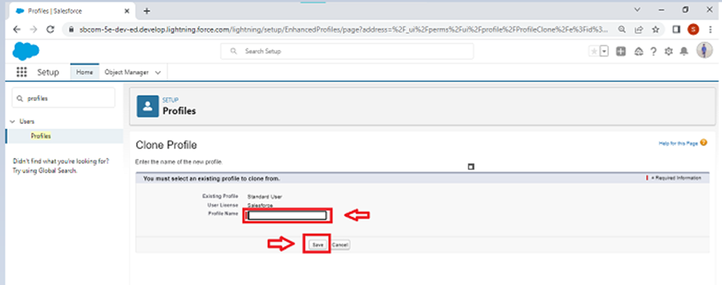

5. While still on the Event profile page, then click Edit

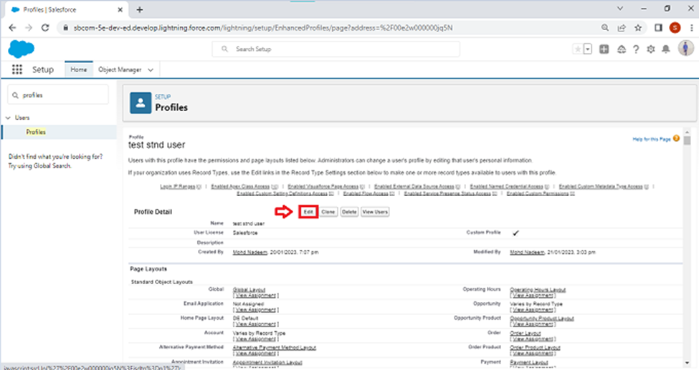

6. Scroll down to Custom Object Permissions and Give view all access permissions to the

Order details, supplier, product, customer, category, payment.

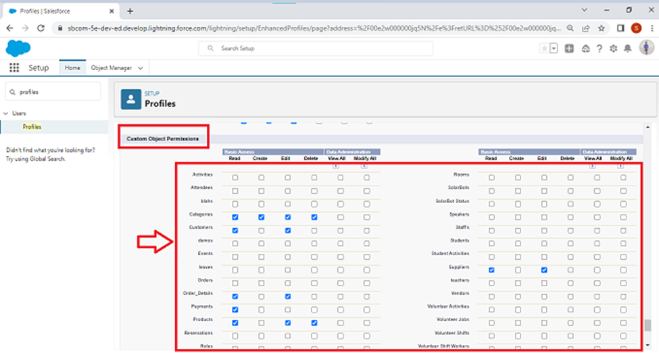

**Create A Profile With The Profile Name As “HR Profile”**

Create a profile with the profile name as “HR Profile”. and give view all permission for interviewer ,position, job application, candidate objects.

### User

What is a user?

A user is anyone who logs in to Salesforce. Users are employees at your company, such as sales

reps, managers, and IT specialists, who need access to the company's records. Every user in

Salesforce has a user account. The user account identifies the user, and the user account settings

determine what features and records the user can access.

NOTE- As Salesforce license can only be used by 2  Users at a time in Dev Org, so If you don’t find Salesforce license then deactivate a user who has Salesforce license Or change the license type from Salesforce to any other.

**Creating A User**

From setup type “users” in quick find and select users, then click New User.  
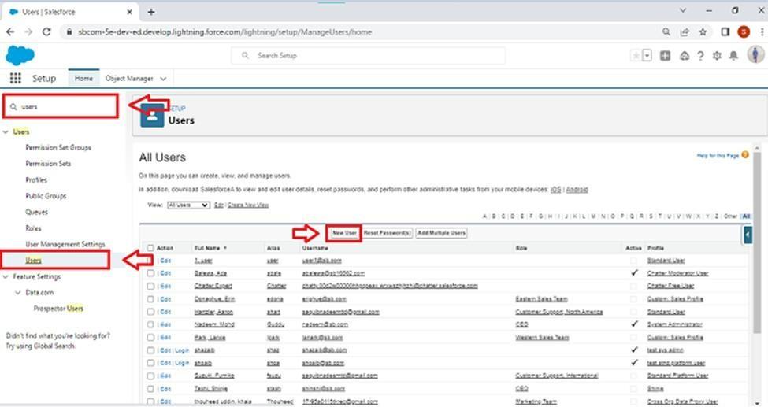

* First Name: Sanjay
* Last Name: Gupta
* Alias: Sanj
* Email: provide your personal email id for future reference
* Username: [sanjaygupta@thesmartbridge.com](mailto:sanjaygupta@thesmartbridge.com)
* Nickname: Sanju
* Role: leave it as default
* User License: Salesforce
* Profile: Hr Profilie
* **Create Another User**
* Create a user with a username as “Abhilash Garapati”, and assign him the interviewer profile

### Permission Set

What is the Permission set?

In Salesforce, a permission set is a collection of settings and permissions that give users access

to various tools and functionality in the platform. Permission sets can be used to grant

additional access to users beyond what is included in their profile, without modifying the

profile itself. This allows for granular control over user access and permissions within the

Salesforce environment. Permission sets can be assigned to individual users or to a group of

users.

### Creating A Permission Set

1. From setup search “permission sets” in quick find and select permission set then click on New

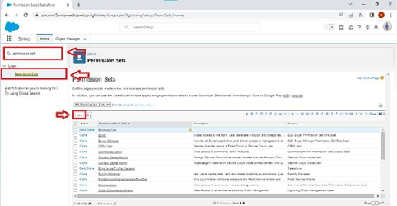

2. Enter label as: Hr Recruiter and Save.

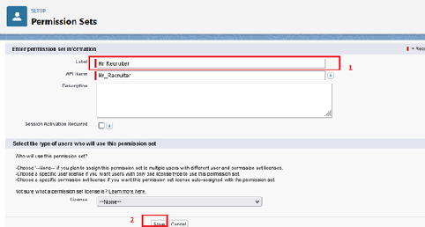  
3. After saving the permission click on objects settings and search review object.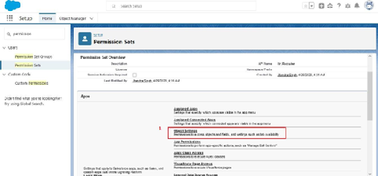

4. Click on edit and give Object permission (Edit) then save.

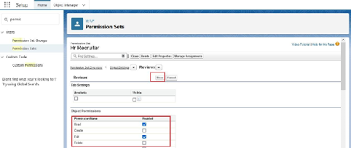

### User Adoption

**Create A Record (Positions)**

* Click on App Launcher on left side of screen.
* Search Recruiting & click on it.
* Click on Positions Tab.
* Click new and fill details & Save.

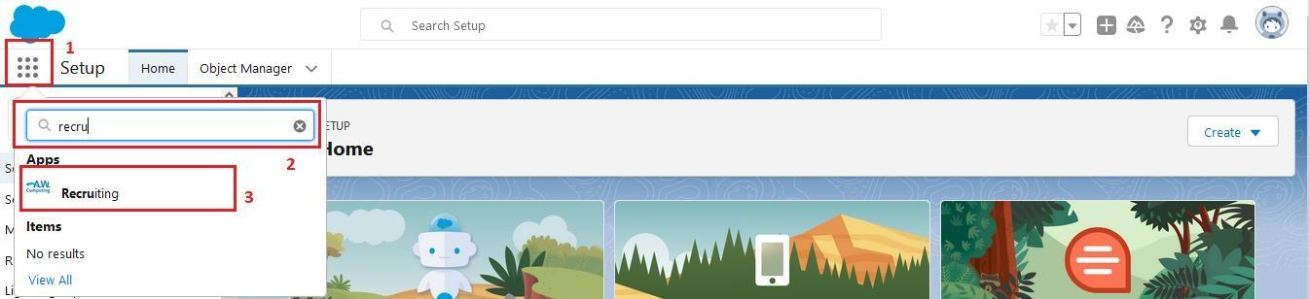

### View A Record(Positions)

* Click on App Launcher on left side of screen.
* Search Recruiting & click on it.
* Click on Positions Tab.
* Click on any record name. you can see the details of the Positions

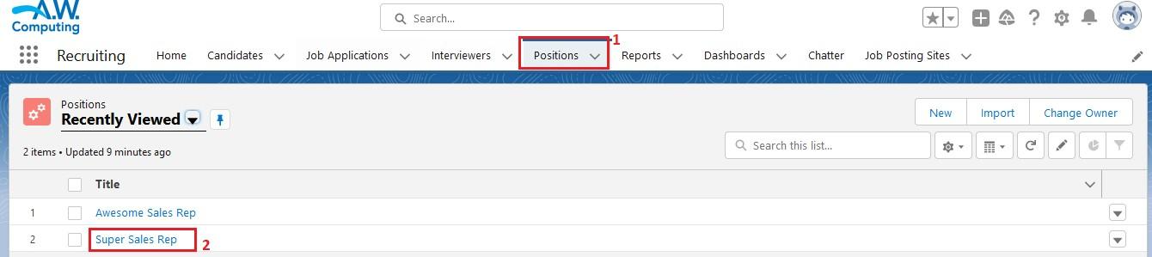

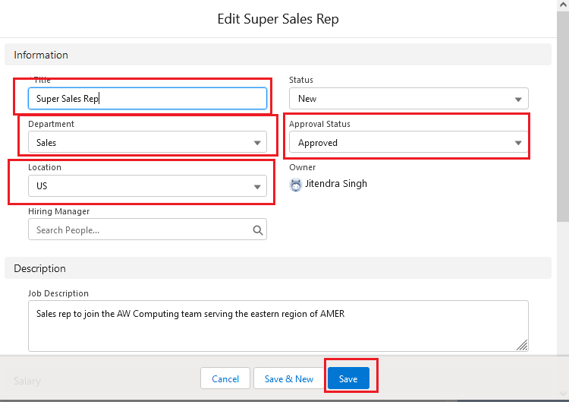

### Delete A Record (Positions)

* Click on App Launcher on left side of screen.
* Search Recruiting & click on it.
* Click on Positions Tab.
* Click on Arrow at right hand side on that Particular record.
* Click delete and delete again.

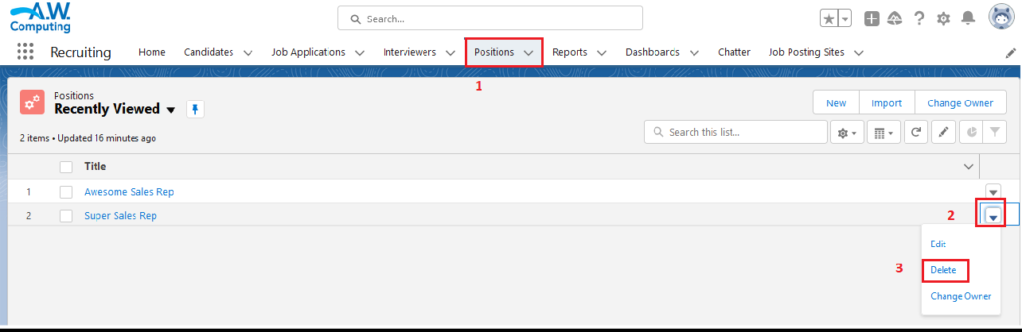

### 

### Reports

What are Reports?  
  
A report is a list of records that meet the criteria you define. It's displayed in rows and columns, and can be filtered, grouped, or displayed in a graphical chart. Every report is stored in a folder. Folders can be public, hidden, or shared, and can be set to read-only or read/write.  
  
  
There are 4 types of report formats in Salesforce:  
  
**Tabular Reports:**  
  
This is the most basic report format. It just displays the row of records in a table with a grand total. While easy to set up they can’t be used to create groups of data or charts and also cannot be used in Dashboards. They are mainly used to generate a simple list or a list with a grand total.  
  
**Summary Reports:**  
  
It is the most commonly used type of report. It allows grouping of rows of data, view subtotal, and create charts.  
  
**Matrix Report:**  
  
It is the most complex report format. Matrix report summarizes information in a grid format. It allows records to be grouped by both columns and rows. It can also be used to generate dashboards. Charts can be added to this type of report.  
  
**Joined Reports:**  
  
These types of reports let us create different views of data from multiple report types. The data is joined reports are organized in blocks. Each block acts as a subreport with its own fields, columns, sorting, and filtering. They are used to group and show data from multiple report types in different views.  
  
**Report types:**  
  
Report type determines which set of records will be available in a report. Every report is based on a particular report type. The report type is selected first when we create a report. Every report type has a primary object and one or more related objects. All these objects must be linked together either directly or indirectly.  
  
A report type cannot include more than 4 objects.  
Once a report is created its report type cannot be changed.  
There are 2 types of report types:  
  
**Standard Report Types:**  
  
Standard Report Types are automatically included with standard objects and also with custom Objects where “Allow Reports” is checked.  
Standard report types cannot be customized and automatically include standard and custom fields for each object within the report type. Standard report types get created when an object iscreated, also when a relationship is created.  
  
Note: Standard report types always have inner joins.  
  
**Custom Report Types:**  
  
Custom report types are reporting templates created to streamline the reporting  
  
Process. Custom Reports are created by an administrator or User with “Manage Custom Report Types” permission. Custom report types are created when standard report types cannot specify which records will be available on reports.  
  
In custom report types we can specify objects which will be available in a particular report. The primary object must have a relationship with other objects present in a report type either directly or indirectly.

**Creating A Report**

1.From the Reports tab, click New Report.

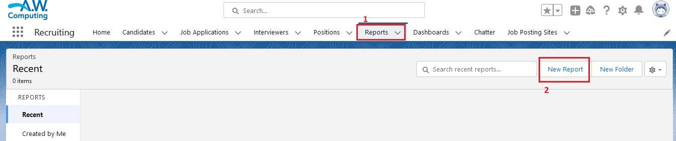

2. Select the report type Job application with position for the report, and click Create.  
  
  
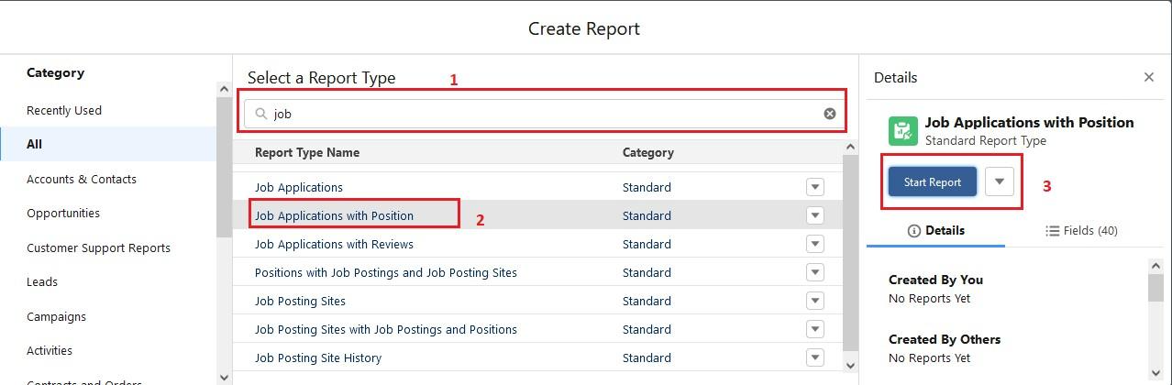  
  
  
3. Customize your report accordingly and include all fields,

Reports needs to be Grouped by one field.(ex - Created by )(require to enable add chart)

Then save (Job application with position) or run it.

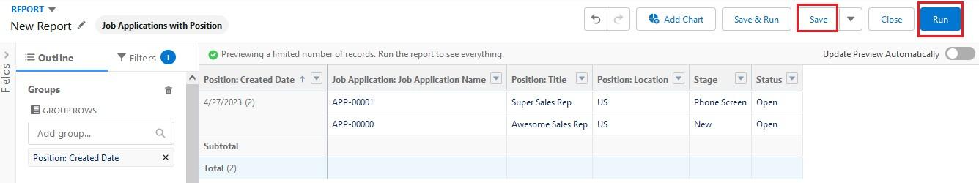

### Create A Report For Job Posting Sites With Job Positions And Positions.

**Dashboard**

Dashboards provide more insights than reports as they combine the data from many reports and show a summarized result. Looking at many reports at a time gives the flexibility of combining the results from them quickly. Also summaries in dashboards help us decide on action plans quicker. The dashboards can contain charts, graphs and Tabular data.

**Create A Dashboard**

1. Click the Dashboards tab.
2. Click New Dashboard.
3. Name the dashboard Job application with position and click Create.
4. Click +Component.
5. Select Job application with position and click Select.
6. Select the Vertical Bar Chart component and click Add.
7. Click Save and then Done.

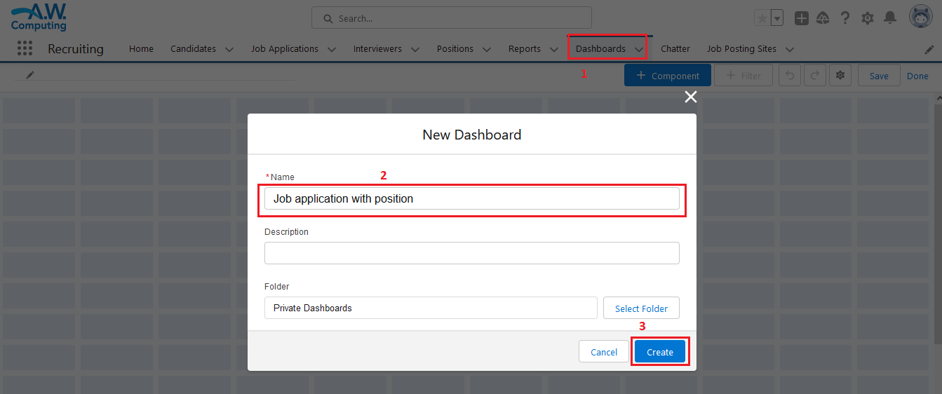

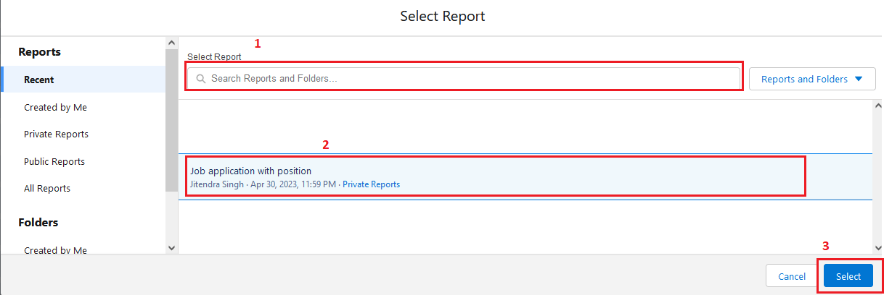

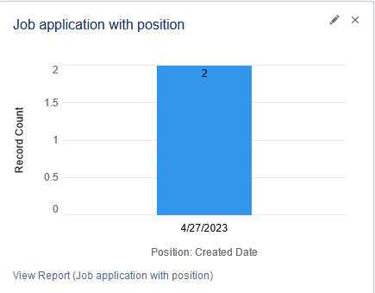

### 

### View Report And Dashboard

**Report**

* Click on App Launcher on left side of screen.
* Search Recruiting & click on it.
* Click on Reports Tab.
* Click on Job application with position & see records

  
  
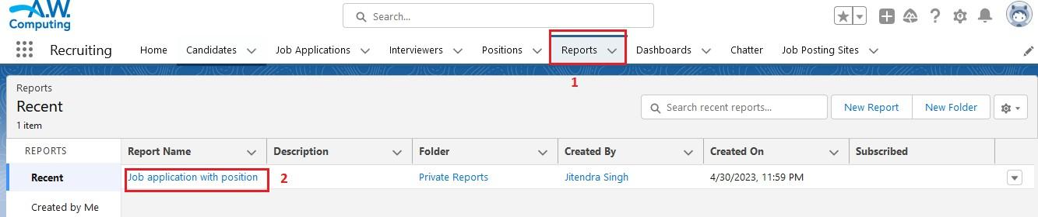

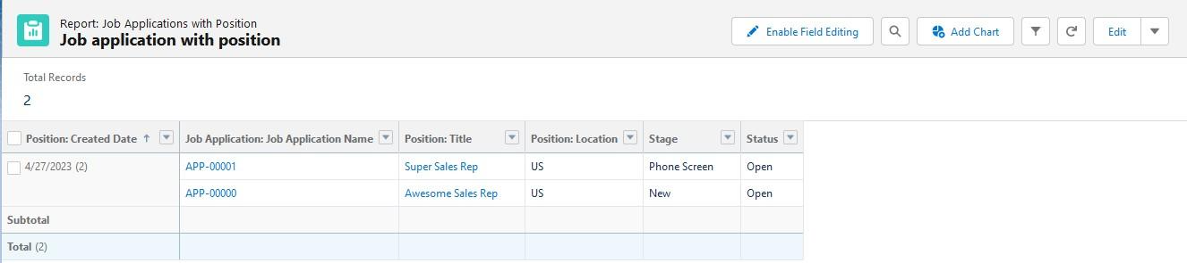

### Dashboard

* Click on App Launcher on left side of screen.
* Search Recruiting & click on it.
* Click on Dashboard Tab.
* Click on Job application with position & see records

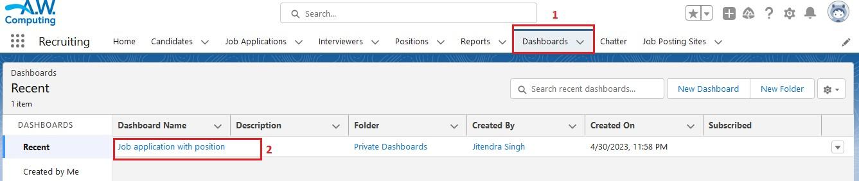  
  
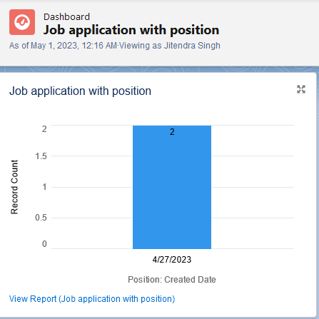

**Apex Triggers**

Apex is a coding language of Salesforce. It can be invoked or started using triggers. A trigger is a set of Apex code that runs before or after data manipulation language (DML) events.

A DML event could be a variety of data processing tasks that include the standard insert, update, and delete commands.

With Apex triggers, you can automate tasks that would otherwise be nearly impossible to accomplish using only the Salesforce user interface. Triggers enable you to create custom scripts that you can implement according to your needs, and the only limitation is your coding skills.

**There are two Salesforce Apex trigger types:**

Before triggers. These are helpful in cases that require a validation process before accepting a change. They run before any database changes.

After triggers. These are helpful in cases where you need to modify your database records and when the necessary value is stored in other records. They run after any database changes.

Both types will help you perform custom tasks and manage records effectively. They can help you perform bulk actions as they can handle several records simultaneously.

### Creation Of The Trigger

**Use Case:**  
HR is struggling!! Not knowing whom to hire on priority so she contacted the developer. Now the developer made the HR task bit easy with this chages . There is the Review__c Object and there is 2 field priority and Recommended for Hire(CheckBox) so condition is like if suppose if we checked the checkbox than priority should be high  
  
**Code lines**

trigger PriorityTrig on Review__c (before insert) {

    List<Review__c> myList = trigger.new;

    for(Review__c rv:myList){

        if( rv.Recommednd_For_Hire__c == true){

            rv.Priority__c= 'high';

            system.debug(rv);

        }

        }

        }

        }

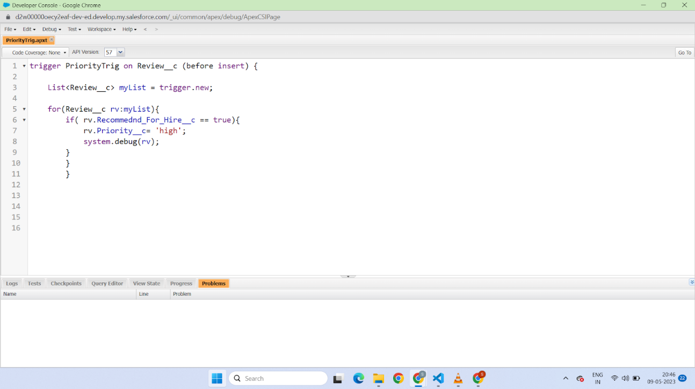

**DML Operations And Batchable**

Create and modify records in Salesforce by using the Data Manipulation Language, abbreviated as DML. DML provides a straightforward way to manage records by providing simple statements to insert, update, merge, delete, and restore records.

Because Apex is a data-focused language and is saved on the Lightning Platform, it has direct access to your data in Salesforce. Unlike other programming languages that require additional setup to connect to data sources, with Apex DML, managing records is made easy! By calling DML statements, you can quickly perform operations on your Salesforce records. This example adds the Acme account to Salesforce. An account sObject is created first and then passed as an argument to the insert statement, which persists in the record in Salesforce.

**Apex Batch**:

Apex Batch For Fetching the records of the job posting site

 The batch class in Salesforce is used to run large jobs (think thousands or millions of records!) that would exceed normal processing limits.

Using Batch Apex, you can process records asynchronously in batches. If you have a lot of records to process, for example, data cleansing or archiving.

A Batch class allows you to define a single job that can be broken up into manageable chunks that will be processed separately.

### Create The DML Insert For The Job Posting Site

**Create the DML Insert for the Job Posting Site**

The HR Manager was looking in the Application and just checking how many candidates have applied for the job and he came to know that there are too many Candidates who applied for the job. So what the HR manager is Doing whenever there are too many Records he stores the information in the Excel sheet as per the month's Records. So he went to the Developer and asked to fetch the Record of the Job Posting Site. So This Task will be Executed with  Apex Batch

**Benefits**:

If suppose Records are getting failed after fetching the 100 Records, so we must try again to execute the Batch Method so it wont start with the starting 100 records it start fetching the records from 101 as batch runs Asynchronously.

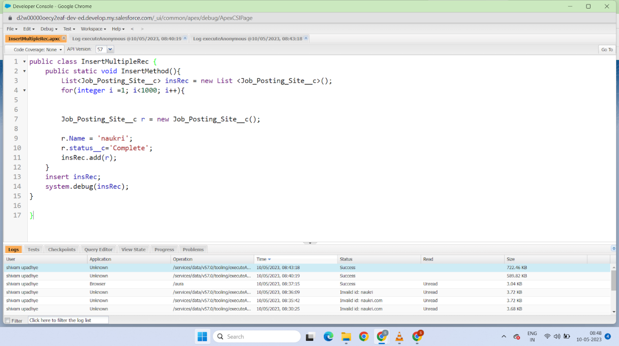

**Code Lines** 

public class InsertMultipleRec {

    public static void InsertMethod(){

        List<Job_Posting_Site__c> insRec = new List <Job_Posting_Site__c>();

        for(integer i =1; i<1000; i++){

        Job_Posting_Site__c r = new Job_Posting_Site__c();

        r.Name = 'naukri';

        r.status__c='Complete';

        insRec.add(r);

    }

    insert insRec;

    system.debug(insRec);

}

}

**Anonymous call for Class And Method(Ctrl+E)**

InsertMultipleRec .InsertMethod();

And Execute

### Create The Batch

**Create the Batch Apex**

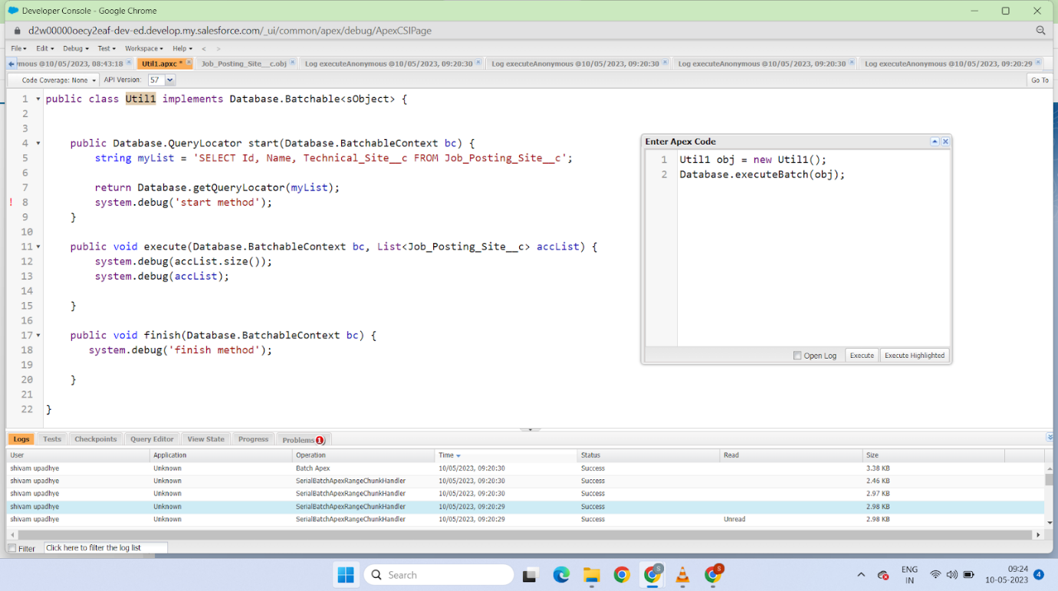

public class Util1 implements Database.Batchable<sObject> {

    public Database.QueryLocator start(Database.BatchableContext bc) {

        string myList = 'SELECT Id, Name, Technical_Site__c FROM Job_Posting_Site__c';

        return Database.getQueryLocator(myList);

        system.debug('start method');

    }

    public void execute(Database.BatchableContext bc, List<Job_Posting_Site__c> accList) {

        system.debug(accList.size());

        system.debug(accList);

    }

    public void finish(Database.BatchableContext bc) {

       system.debug('finish method');

    }

}

**Anonymous Code to call the batch class**

Util1 obj = new Util1();

Database.executeBatch(obj);

### Check The Batch

**Check the batch**

Click on the gear icon

? click on setup

? Click on the home button and search for

? Apex Jobs than you can see the success of the chunks it run 200 batch for the total record

